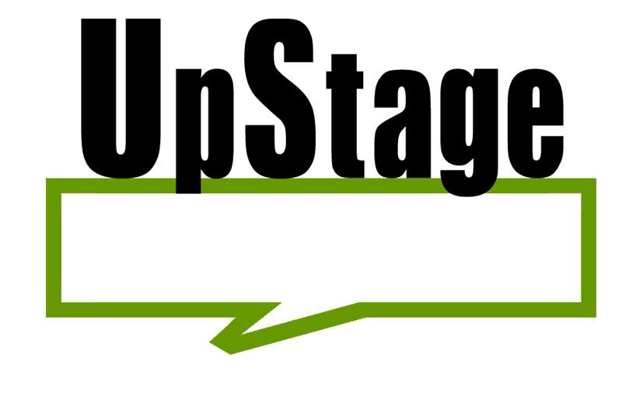

**Mid-project Progress Review**

**Semester 1, 2015**

**Team Clients**

Charlotte Paterson 1243532 Helen Varley Jamieson Gaoxin Huang 1136424 Vicki Smith Yue Li 1251124

**Supervisor**

Anne Philpott

Table of Contents

2 The Project 3

2.1 Objectives 3

2.2 Scope 3

2.3 Approach 4

2.4 Planned End Deliverables 4

2.5 How Original Proposal Conditions Addressed 5

2.6 Variations from Proposal & Rational 7

3 Project Status 7

3.1 Team Achievements 7

3.2 Difficulties Met 7

3.3 How Issues Managed 8

4 Project Team Recommendations 8

4.1 Project Development Methodologies 9

4.2 Team Roles Reallocation 10

5 Individual Work 11

5.1 Yue 11

5.1.1 Ongoing Activities 11

5.1.2 Work Completed in Semester 2, 2014 11

5.1.3 Summer Holiday 12

5.1.4 Reflection on Learning 14

5.2 Charlotte 16

5.2.1 Time Tracking 16

5.2.2 Tasks completed 16

5.2.3 Issues and Improvements 17

5.3 Gaoxin Huang 18

5.3.1 Time Tracking 18

5.3.2 Tasks 19

5.3.3 Learning 20

5.3.4 Improvement 21

6 Appendix 22

7 Version 23

# The Project

UpStage is an open source web-based application where users can participate in online digital performances. This project has been ongoing since 2004 and has had various teams throughout its creation. The main goal for semester two in 2014 was to initiate new UpStage redesign. This was to be done by determining the current technologies UpStage uses for its features and compare with recent technologies, whilst also maintaining the current version 3 code.

## Objectives

1. Determine 3 potential front-end technologies for Flash replacement with the corresponding proof of concepts.
2. Deliver evaluated prototypes for suitable technologies for further UpStage development.
3. Deliver a solid research strategy based on Design Science principles.
4. Maintain UpStage version 3 for current users.

## Scope

1. Complete the evaluation document for Flash replacement prototype during semester 1, 2015.
2. Complete a research report on the feasible technologies for Flash replacement by the end of semester 1.
3. Complete a solid research strategy which based on Design Science principles prior to project completion.
4. Maintain effective communication with clients and UpStage community throughout Semester 1, 2015.

## Approach

Based on the research focused nature of last semester goals we did lots of discussion around what kind of methodology was appropriate. We could not use the same techniques the previous team used as we did not want to focus on adding to the current design we needed a way to evaluate research in a way that would produce deliverables. In this we were presented the idea of Design Science which allows us to look at a problem or area in the current UpStage and create prototypes of possible solutions. This methodology helps us achieve the goal of researching recent technologies.

We also used a the peer programming practice taken from XP which allowed us to become familiar with the current version 3 software, whilst also achieve our goal of maintaining the current system.

## Planned End Deliverables

* Proposal
* Mid-semester Status Report
* Developer Blogs
* Evaluation Document of technologies for Flash replacement
* Proof of concepts for Flash replacement
* Result of research for planning and practice in Semester 1, 2015
* Project Portfolio
* UpStage poster for Semester 1, 2015
* Individual Reflective Reports

## How Original Proposal Conditions Addressed

“*Apart from a plan for the full period of the project. Plan only covers first semester.*”

We have appended a new plan for semester 1, 2015. There is a detailed plan in the appendix for Semester 1, 2015.

“*Several different approaches are outlined though it is not made clear how they will all work together. More detail was needed here to make clear what was proposed. How will Design Science be used? How can Kanban be combined with SCRUM. Why would it? What weakness does it address or advantage does it bring? Team should look at a clearer specification of the approaches and the practices so you are clear what you are using and why.*”

Design Science will be used as a guideline throughout team research and prototyping activities. Design Science encourage researchers to come up with questions for particular topics, and then the researchers can turn the questions into specific artefacts for later prototype evaluation process. By applying Design Science processes as stages for conducting team research, team will produce consistent and relatively coherent results.  
After our first semester’s experience, team concluded that Scrum and Kanban would bring little value for UpStage redesign. Both Scrum and Kanban are sophisticated for project production process; however, our project currently needs more research input for seeking the potential elements of future UpStage.

Team is aware of Design Science has following weaknesses:

1. Does not identify how to come up with artefacts.
2. Does not define a certain time frame for each process.
3. Research development processes can go forward and backward. Lack of guideline.

We must take time constraint into our project lifespan. During semester 1, we will not hold our research progress by any difficulty. Team members will document the difficulties on the specific technology evaluated, and move onto the next technologies. There are many front end platforms to evaluate, so any slack will have negative impact on later prototyping steps.   
The solution is to write up daily individual developer logs for the researching team members, so that we can keep track what tasks are accomplished, which tasks are not attempted, and why tasks are skipped by developer. This solution aims to reducing duplicated work for the future UpStage teams.

“*This area of the proposal lacks details about the near future and any information at all about the second semester. The plan for the near future should include dates, activities and deliverables. The proposal does not make it clear why there is an ongoing regular maintenance commitment.*”

Our clients and UpStage community still use UpStage on the public server for performing shows and events. Withdrawal maintenance of UpStage V3 will result the full deprecation of current product soon. Meanwhile, our new product cannot be produced immediately to satisfy the needs of UpStage community. Finally, AUT UpStage teams have been learning from the current implementation to gain the insight of cyberformance. Remove the focus from UpStage will demolish last 10 years contribution from previous members. We want to see UpStage continuously making progresses in the long run. This is why we have kept long term support of current UpStage product.

“*The section on QA does not include any coverage of the QA practices that will cover the design science phase.*”

Design Science provides a unique way to assure quality of work done by developers. Design Science encourage qualitative artefacts as the critical evaluation criteria, researchers and developers must strictly satisfy the artefacts’ need. This will assure quality before the research commences. Design Science also involve development in iterations, and developers must write their own logs towards the prototype evaluation in the end of each iteration. Both pre and post quality checks will validate whether the researchers’ working track, and report issues accordingly.

## Variations from Proposal & Rational

In our proposal, we wrote new UpStage initiation/redesign. We came up with 3 different research areas in Flash, Text-to-speech, and Video Streaming technologies replacements. In the first semester's research, we conducted our research topics in a parallel manner. Our research results were loosely connected. As a result, the outcome of our first semester research was not convincing.

For the second semester, we want to try something different. We want to focus on Flash replacement as our research foundation. Both Text-to-speech and Video Streaming technology need to reside on the new technology in replace of Flash. If we can make an adequate amount of effort on Flash research, we will ease the heavy overhead for future UpStage development.

# Project Status

## Team Achievements

During semester 2, 2014, there was little achievement by our team. Team struggled on how to proceed its research area and the particular development. This circumstance resulted team to look into how to manage team activities and maintain team in a healthy and active state. The biggest achievement of 2014 was when Anne said our research went to wrong direction. Then team learned from this lesson, and start looking for possible solutions in order to tackle the similar situations in the second half of our project.

## Difficulties Met

Our team’s difficulties are in:

* Did not fully understand UpStage.
* Overly optimistic on final year project.
* Lack of detailed actions in semester 1 commitment.
* Collaboration and work distribution among team members

## How Issues Managed

* Since the most urgent issues in the current product are concurrency issue. Concurrent issues are beyond team’s capability to manage. Team could only provide some enhancement on the product presentation and convenience. There was hardly any work completed on fixing bugs except #200 fix by Yue and Mikhail and #16 by Mikhail.
* In the beginning of November, UpStage 8081 (with the latest V3 code) posed critical issues. Issues are:
  + Different backdrops showing on the stage for different users.
  + Voice does not match the avatar.

When team received issues from clients, we investigated the possible causes. We recommended our client to use 8083 for the coming performance as 8083 was used during UpStage 10th year anniversary event. At the time, there was no error reported.

* We also encountered issues on public server. Maybe the server was loading too much data, it had frequent crushes in the end of year 2014 and the beginning of semester 1, 2015. Team communicated such issues with UpStage community. We concluded the server had many different applications running at the same time, and caused the server to freeze. Paul made some extra space on the server, then the can runs.
* During summer holiday, we had issues on AUT UpStage server. The server has been replaced by new machine with Windows 7 system. We cannot add new members into our SVN. It was also difficult to test the current implementation. Meanwhile, UpStage’s main site is down. There was little help for our new team members to get good understanding of UpStage project prior to their project proposal. Team discussed with

# Project Team Recommendations

* Review of current plan
* More team meetings
* Have document templates for deliverables to be completed at the end of two week iteration (regardless of progress)

## Project Development Methodologies

For the methodology part, we will use Design Science as a guide for defining all the research stages.

*Design Science Steps*

* Define Problem (artefact, the features we want to achieve in the new prototype)
* Background Research (what the problem is in the current implementation)
* Select technology (From a wide range of technology pool)
* Develop prototypes to satisfy the particular task (artefact focused development, not the entire product)
* Evaluate the prototypes based on how the target goal was managed. Eliminate all the undesired technologies as project progresses.

Team will investigate 10 to 15 different front end technologies, and prepare evaluations for each technology. Candidates are: Bootstrap, Foundation, Sematic-UI, Susy, Material UI, MaterializeCSS, Gumby, Pure, Metro UI CSS 2.0, Leaf Beta, IVORY, AngularJS, Kickstrap.

*Communication*

* Discussions over Facebook group page.
* Blog posts for UpStage community.
* Supervisor meetings.
* Communicate with different developers via emails.
* Possible more frequent client meetings.

## Team Roles Reallocation

|  |  |  |
| --- | --- | --- |
| Roles | Description | Assigned To |
| Problem Solver | Solve collaboration problems. When a problem arises, the Problem Solver’s decision is final. | Charlotte Paterson |
| Software Developer / Researcher | Perform all the programming / research assignments | All |
| Quality Assurance | Validate planned schedule against the progress of the team. Assure the quality of team’s work | William Stokes  Yue Li |

# Individual Work

## Yue

In the beginning of my project, I allocated 1 hour on each day throughout my final year study. Between July 24th, 2014 and June 21st, 2015, I can contribute 333 hours to my project. Such amount of hours will meet the criteria of 300 hours commitment. At this stage, my actual work time went over my initial estimation by a large amount. I committed 126 hours in the semester 2, 2014, and 147 hours during summer holiday. I would like to commit around 100 hours during semester 1 2015. By committing such amount of work, I will gain sufficient experience in software development practice and research.

### Ongoing Activities

I write drafts for our fortnight developer blogs since the beginning. I consider developer blogs are quite useful for keeping the communication between UpStage community and our team. Our clients use developer blogs to track of team activities, and provide advice. I will carry on writing Blogs frequently to make sure UpStage community receives team activities often.

### Work Completed in Semester 2, 2014

During semester 1, 2014. I divided my work into 3 areas:

* Bug fixing / Version 3 Code enhancement on ticket #200
* Research topic on Video Streaming technologies
* Participate Regression test

I resolved bug ticket #200 with Mikhail Chen on UpStage Git repository. I researched on Video Streaming technology with Mikhail. Since there was no clear guideline of our research, we performed a breadth-first search on all possible technologies, and evaluated them at my best thoughts. I did not expect my research would become far-fetched. When I realized all team members fell into the same situation, I started doubting performing research in a “breadth-first search” manner as the main method of our research. This experience resulted me looking into the current UpStage implementation and seeking for an alternative research approach. On the day of regression test, I found the current regression tests only validate the UpStage website instance, not the UpStage web application. After I communicated with Takuma Sato, he said we should only focus on the tasks not to question whether the task’s correctness.

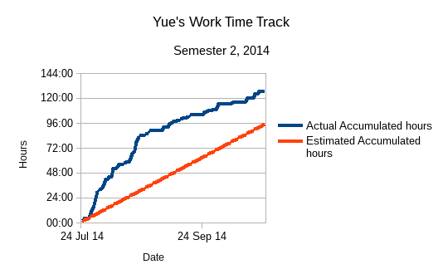

### Summer Holiday

I committed 147 hours during summer holiday to obtain sufficient knowledge on the previous teams' work and Design Science. I came up with a research idea for conducting our research in semester 1, 2015. Design Science encourages researchers to come up with an idea/artefact, and use the artefact to evaluate the result of experiments.

UpStage’s requirement is complete. I can use the requirements as artefacts, and build up prototypes accordingly. Throughout the holiday, I monitored NPAPI deprecation via Chromium team blogs. Because of NPAPI deprecation, I promoted Flash-related research over the others. ActionScirpt 3 plays an important role on the client-end of current UpStage product. When I had firm grasp of UpStage’s features, I thought maybe I could write the same features in different technologies without ActionScript (considering ActionScript’s propriety status). Then I found NodeJS, HTML5 Canvas, Bootstrap, CSS3, and JQuery. While implementing part of the features, I also found Bootstrap advocates Mobile-first development. This also meet some desired features from UpStage's shortage ─ Mobile support.

As I worked on my own, I received good advice from UpStage community, and all the information helped me to have better understanding of UpStage.

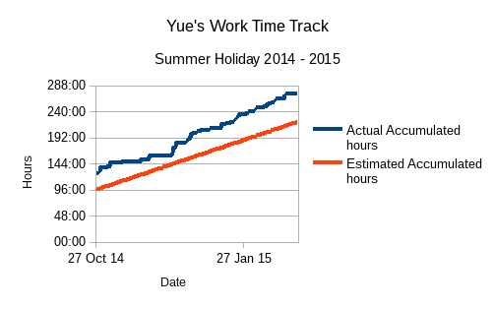

### Reflection on Learning

In the last 8 months, I earned valuable experience. Especially in team effort and communication. In addition, I developed communication and technical skills as a software developer and quality assurance. I have summarized my software development and research experience as below:

* *Learn from Failures*

I make failures during project research and development activities. The mistakes contribute a large amount of experience to my individual development. Among all the mistakes, the outcome of my team's research topics forced me to think whether there is possibly a better way of performing team research. The failures also lead me thinking if we can combine the processes of Design Science and other techniques for the new semester team activities.

* *Writing Developer Blogs*

Preparing developer Blogs enhances the communication between AUT UpStage Team with the external UpStage community. This increases the chances of receiving feedback/assistance when team has some difficulties, especially in understanding the current implementation.

* *Planning and QA are Important*

I had a blur understanding on the current implementation. Without the proper guidance, I struggled finding the correct way of learning and contributing to the team. I think, in order to be an efficient and effective team, a solid plan must present for team members to follow. Moreover, a sophisticated QA must periodically verify and validate the team's work. For the new semester, I would propose a different approach to make sure my team is on the right track.

* *Team Commitment Drives the Project Outcome*

During the work done in the semester 2, 2014 and summer holiday, I concluded that sufficient commitment from each team member will become the most important element towards project success. How to contribute work equally has become an issue among team members. I discussed this situation with lecturer, Jim Buchan. After the discussion, I learned people are different. I think in the next semester, I will try to acknowledge others' work when we address issues with the team environment.

* *Questioning Skills*

When I started my final year project, I found all my knowledge from previous years did not help me directly. I never formally came across ActionScript and Python. I did not know how to configure a server in Debian system. Neither had I no clue about Design Science. In my first semester, I was busy doing what I was told to do until Anne told the whole team about our research irrelevance to our goal. After that I spent time thinking why and how we did our tasks wrong. I concluded as:

1. The whole team is lack of commitment driving our project. Team members leaned to our supervisor for instructions.
2. There was little information about what to accomplish, how to achieve the tasks in details, how to manage unforeseen incidents. When there is no clear planning, our project will fall.
3. We must take the responsibilities for our work and our project outcome.

Since then I started thinking in: “What are the requirements of UpStage in the motivational document? What need change? Why we make change? What features new technologies should have? Is there any lightweight framework for fast-paced development?” By converting ideas into questions, I could look for answers. I also find questioning helps me on self-directed learning.

* *Technical Skills*

In the first half of my project, I learned how to setup Debian server instance for UpStage V3. I worked on JavaScript code on the UpStage site. I practised collaboration tools such as Git and SVN.  
During summer holiday, I studied how to use Node.JS, HTML5 Canvas, Bootstrap and JQuery to create a responsive single-page web application. I practiced how to use Embedded Javascript template to manage front-end code. I used JQuery to control the events of Node.JS application. I learned how to use JSON package specification and NPM (Node Package Manager) to deploy my Node.JS application.

## Charlotte

### Time Tracking

I started UpStage in second semester of 2014. UpStage is unlike any project I have done at AUT before. I believe coming into an existing team and working on an existing product is a valuable experience. However it has also been very challenging. I set the goal of 150 hours for my first semester, then I could complete 150 in my second semester. After calculating my hours recorded in my book I have only done 42 hours so far. I found that I did not accomplish as much as I would have liked as I spent much more time on my other papers as I felt I had more leniency in the deadlines for this paper. To prevent this from happening this semester I will focus on tracking my progress more carefully and review my progress over a weekly basis.

### Tasks completed

As per the plan created for our portfolio, we were to research an assigned area of UpStage and produce a proof of concept based on Design Science Methodology. The research topic I worked on was Text-to-Speech with James. While James looked into how the current Text-to-Speech Festival MBROLA worked, I looked into alternatives that could be used such as CMU Arctic and eSpeak. We made a comparable matrix on all the benefits each of the voice technologies had with the current UpStage Text-to-Speech technologies.

The second part of the plan was to maintain the current UpStage version 3 software. I only looked into one bug which was around creating an invisible Avatar. However I struggled with this and eventually gave up on finding a solution with no deliverable produced.

I also did quality assurance on the motivational document and wrote up the meeting minutes.

### Issues and Improvements

I found that my biggest downfalls were time management, progress tracking and finalizing a product. As my time was mostly spent on other papers I let my work slip in this project, this in turn was largely due to my lack of progress tracking. To ensure I stay on task I will allocate time at the end of each week to review my individual progress. Also an increase in team meetings will help ensure members are following the plan. As I was not following weekly progress on the plan, I was not producing the deliverables I was supposed to by the time set out by the plan. I will improve my productivity by sticking as closely to the plan and producing deliverables on all work, even if it did not produce the result expected result.

## Gaoxin Huang

### Time Tracking

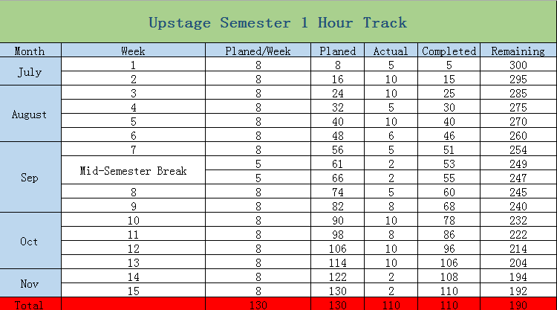

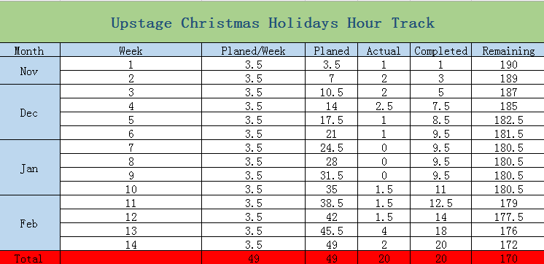

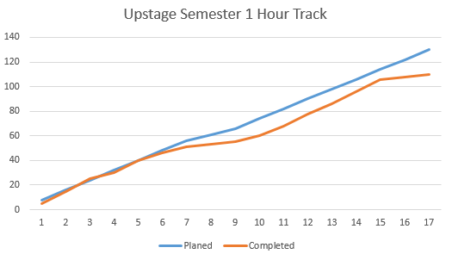

Originally, I planned to complete 150 hours in semester 1. However, I was busy for other classes and their assignments. Indeed, I have completed essential tasks which I got, but I did not have time to expand the tasks and did better in them. Thus, I planned 49 hours to remedy it in my holiday, but I got a job and I spent a lot of time on it and the job project. In this semester, I still have 170 hours to work, I believe I can achieve it and do more contributions to the project.

### Tasks

* Project proposal---It is my first task for the project. I did methodology part and skill part. Indeed, I tried to find and use the suitable methodologies and skill to the proposal by what I learnt in the classes. In addition, I gave some ideas and helps to other parts.
* Lean and understand the current project---Our project is a heritage that previous teams leave to us. Thus, I needed and completed to understand the current project. It enables us to design and manage the project.
* Fix Bugs---There are a lot of bugs in current version of the project. In fact, each of us had these bugs to fix. I remembered I fixed one of them was to put save button in suitable position.
* Research in Flash and HTML5---The project is an “old” project with 10 years, so some of techniques need to replace. In this way, I got a task for research in replacement of flash. Then we found HTML5 may be useful for the replacement. Therefore, I did research in comparison of Flash and HTML5.
* Testing Compatibility---In the last semester, I got a task which was testing compatibility in version 3 of project. Indeed, my work was testing whether the latest Chrome supported to our projects.
* Prototype (continue) ---To build new UpStage, we need to design the prototype at first. It is a big challenge for us, because I, as a student, need to learn the latest techniques for taking them to our project. It is still in process step by step.
* Learning HTML5, JQuery and AngularJS (continue) ---These skills will be working for prototype. Learning them for prepare to design the prototype of project.

### Learning

* Semi-Professional Environment---I, in this project, am working in a semi-professional environment, which gives me horizons in working companies before my graduation. In fact, it pushes me to adapt working companies in advanced.
* Problem-Solving Skill---In this project, I faced a few of problems which I have never seen. Thus, I tried to gain ideas in the Internet and discussed with other team members. For instance, I had not heard what the replacement of flash should be. To complete the task, I searched a lot of material on the internet and discuss with my partner to perform the task.
* Communication---Communication is an essential skill in the project, I, in the project, found and understood the four steps of communication. The first of step is listen. Indeed, listening to ideas and solutions from other team members. Then we need thinking. The third of step is asking, asking some question which we do still not understand. Lastly, we present our idea basing on the above steps.
* Methodology---Although I learnt a lot of methodologies before I started the project, I really used the methodologies and learnt new methodologies, such as Design Sciences, in the project.
* Working with Legacy Code--- The vital thing that I have learnt during my time working on UpStage, is the difficulties that are working on an “old” software that needs designed and maintained. Therefore, it pushed me to learn how to maintain and work in legacy code and I got the experience from the project.

* Programming Language---There are a lot of programming languages in the project, such as Python, CSS, ActionScript, HTML and JavaScript. In addition, the team push me to learn HTML5, JQuery and AngularJS to prepare for the next stage or new UpStage. All of programming languages enable me to obtain competitiveness in my future.

* Version Control Systems---The project offers some professional version control systems for us to control and manage the project, such as GitHub and SVN. In fact, some of the systems are really a requirement in companies’ recruitment.
* System---The server of project is basic on Debian system, which requests us to understand and operate the system. Thus, I learnt some commands to control and run our project.

### Improvement

Working on UpStage has taught me a lot of knowledge and given me work experiences, However, in the last semester, I, as a new member, did some tasks which was most for me to understand the project. In this semester, we will try to be the host of the project and do better than last semester.

# Appendix

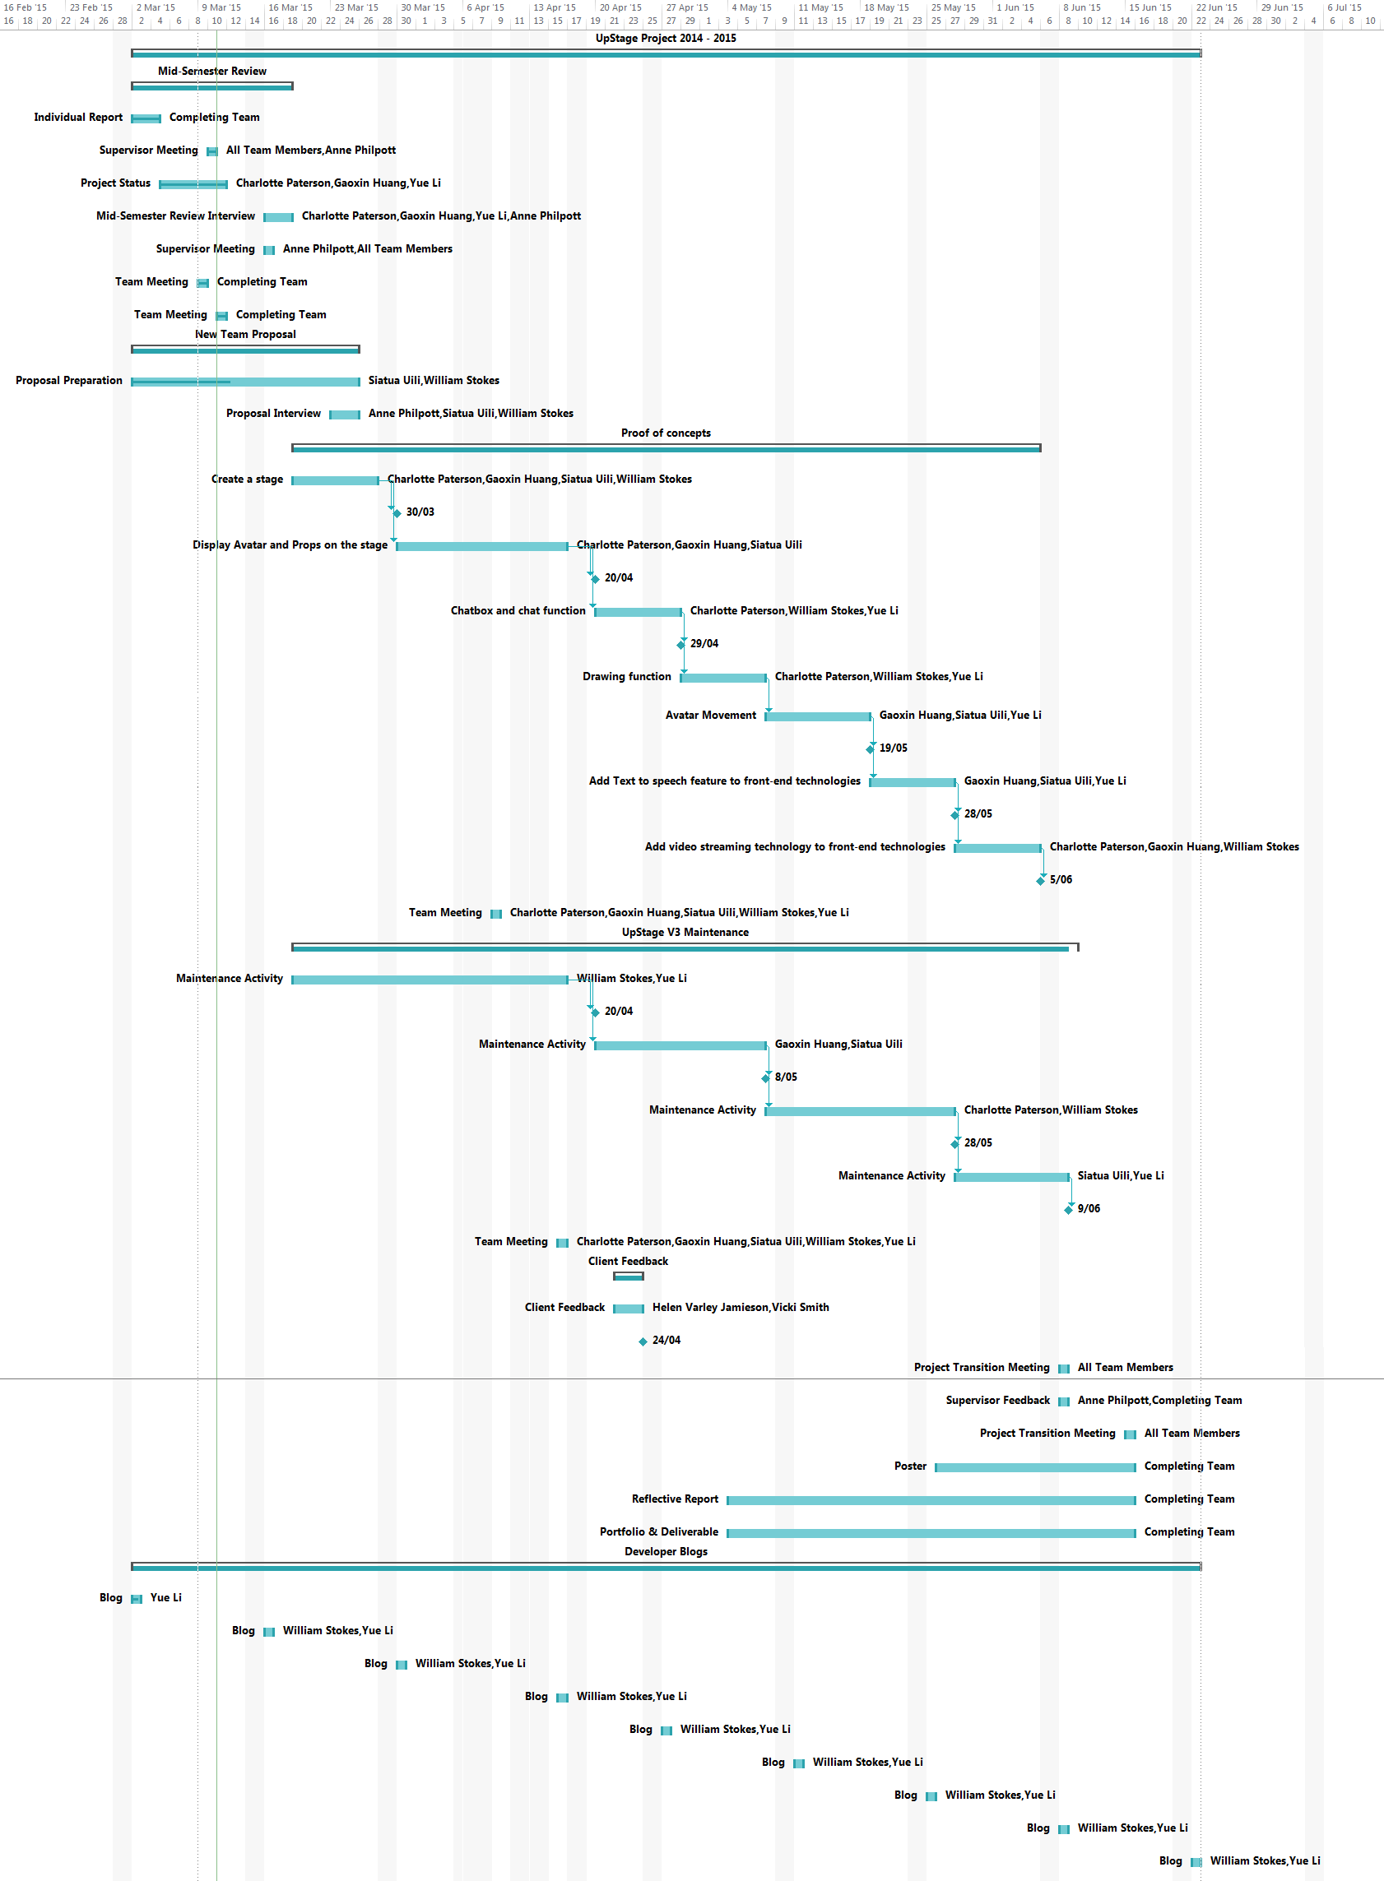

Semester 1, 2015 Detailed Plan

# Version

|  |  |  |
| --- | --- | --- |
| Version | Person | Date |
| V1 | Yue | 10/03/15 |
| V2 | Yue | 11/03/15 |
| V3 | Yue | 12/03/15 |
| V4 | Yue | 12/03/15 |
|  |  |  |